**MZUMBE UNIVERSITY**



**FACULTY OF SCIENCE AND TECHNOLOGY**

**PROGRAM: FST**

**COURSE NAME: DIT I.**

**NATURE OF WORK: GROUP ASSIGNMENT.**

**SUBJECT NAME: MAINTAINING COMPUTER SYSTEMS.**

**SUBJECT CODE: CSS 062.**

**LECTURER NAME: MR. KURIHO**

**GROUP MEMBERS. GROUP 5**

|  |  |  |
| --- | --- | --- |
| **S/N** | **STUDENT NAME** | **REGISTRATION** |
| **1.** | **Eroli Mabali Eroli** | **14233050/T.23** |
| **2.** | **Dickson Musa Thomas** | **14233038/T.23** |
| **3.** | **Fortune Evarest Lazaro** | **14233032/T.23** |
| **4.** | **Ally Kassim Masinga** | **14233040/T.23** |
| **5.** | **Nadya Buda Martin** | **14233006/T.23** |
|  |  |  |
| **6.** | **Jenipha Braison Natai** | **14233011/T.23** |

Our objective Activities were including: -

1. Microsoft office installation.
2. Windows activation.
3. Anti-virus installation.

**INSTALLATION PROCESS.**

1. **MICROSOFT OFFICE INSTALLATION**

According to our Computer, the user was required to be Installed a Microsoft office 2016 pro for their different uses, therefore we have Installed a Microsoft Office 2016 Pro by considering the Microsoft Office Installation guideline or procedures as follows below: -

**Insert the Installation Media: If** you have a CD/DVD, insert it into your computer's optical drive. If you are using a USB drive, insert it into a USB port.

**Open the Installation Drive:** Once the media is inserted, open File Explorer (Windows) or Finder (macOS) and navigate to the drive containing the Office installation files.

**Run the Setup Program:** Look for the setup executable file (often named setup.exe or something similar) and double-click it to start the installation process.

**Follow the Installation Wizard:** The installation wizard will guide you through the installation process. You may be prompted to enter your product key during this process, so have it ready.

**Choose Installation Options:** You can typically choose the version of Office you want to install (e.g., Home & Student, Home & Business, Professional), select the installation location, and customize other options as needed.

**Complete the Installation:** Once you have selected your options, proceed with the installation. The process may take some time depending on your computer's speed.

**Activate Office:** After the installation is complete, launch any Office application (such as Word or Excel), and you will be prompted to activate Office. Enter your product key when prompted to activate your copy of Office.

**Updates and Activation:** After activation, it's recommended to check for updates to ensure you have the latest features and security patches. You can do this by opening any Office application, going to the "File" or "Help" menu, and selecting "Check for Updates" or a similar option.

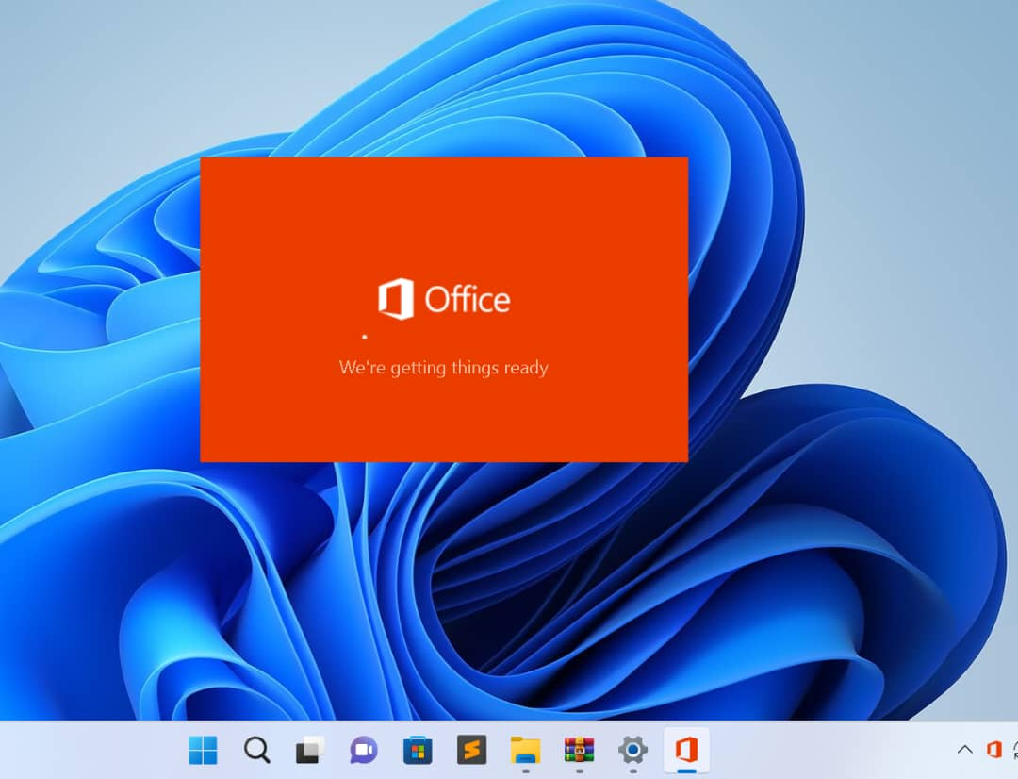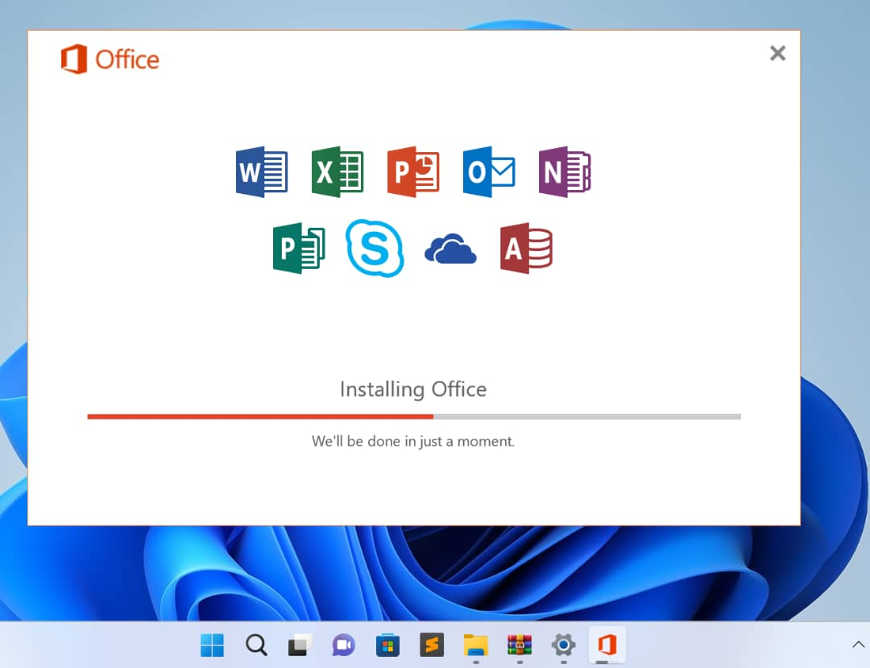

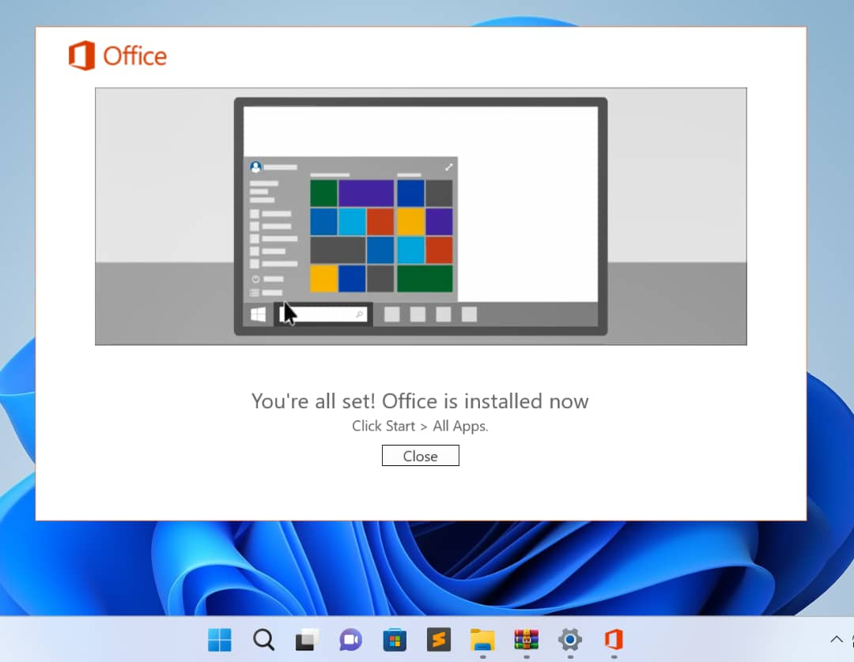

1. **ACTIVATION AND TOOLS USED.**

**WINDOWS AND MICROSOFT OFFICE ACTIVATION**.

On most computers there are some effects of using windows without activation. They include;

* Microsoft offices fail to work at their highest performance.
* Automatic shutdown.
* A watermark appears on the desktop icon.
* Limited functionality.
* Reduce security as you may not receive important.
* Limited personalization.

Also, failure of activating Microsoft office may result into the followings aspects;

* Watermarks in documents.
* No updates.
* Windows and Microsoft office were activated by using digital license known as KMSpico.

Microsoft Windows and Microsoft Office were Activated successfully by using a digital license known as ***KMPSpico*.**

**The following are the procedures used during** Microsoft Windows and Microsoft Office activations: -

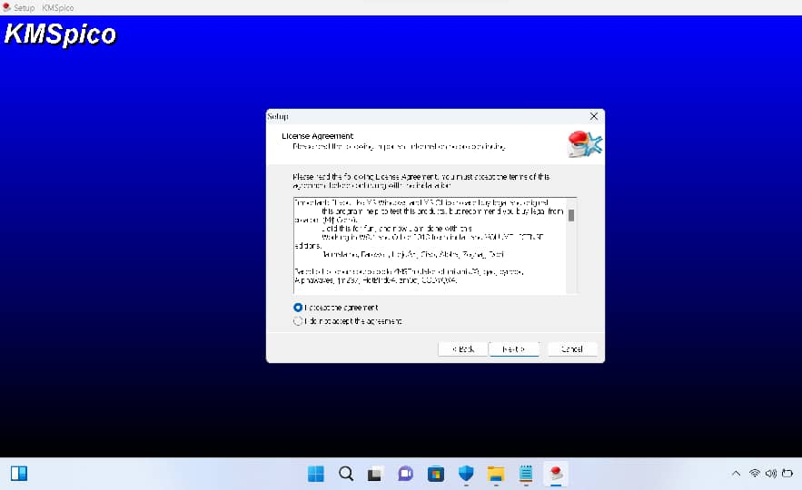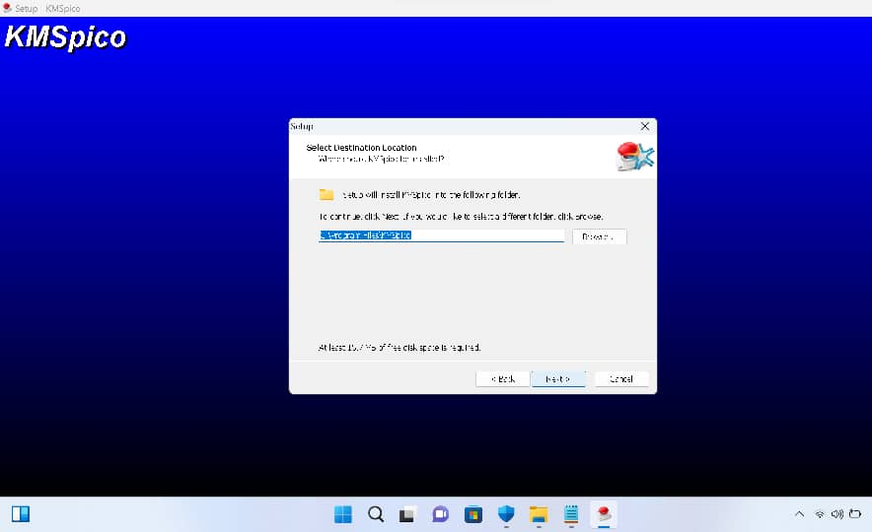

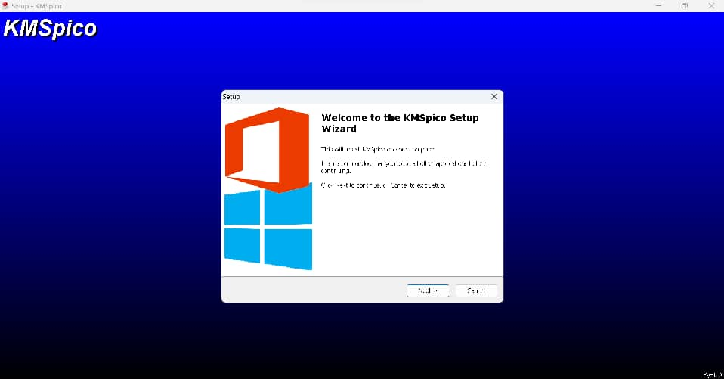

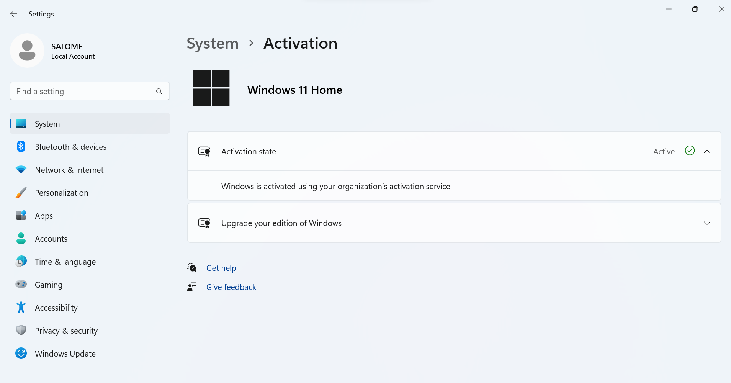After Microsoft Windows and Microsoft Office activation, the Microsoft Office was ready for the use while Microsoft Windows was activated also as shown below: -

1. **DEVICE SPECIFICATIONS.**

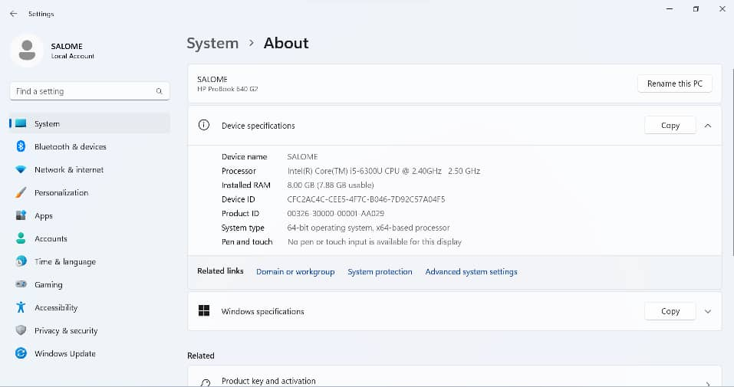

|  |  |  |  |  |
| --- | --- | --- | --- | --- |
| **S/N** | **Generation.** | **Device Specifications.** | **Windows Specifications.** | **Memory.** |
| 1. | * HP ProBook G2 | * Processor – Intel(R) Core (TM) i5-6300 CPU @ 2.4GHZ 2.50 GHZ | * Windows 11 Home * Version 22H2 | * Installed RAM 8.00GB * ROM 500GB (HHD). |
|  | |  | | |

1. **ANTI-VIRUS INSTALLATION.**

There are various types of anti-virus software, each with its own unique approach to protecting your computer from malware. They include;

* Avast Anti-virus
* AVG
* Panda Anti-virus 2016
* Microsoft Defender
* Heuristic based antivirus, this program detect malware based on typical behavior rather than specific signature.
* Full system scanners, this antivirus programs perform comprehensive scans of your entire system to detect and remove malware.
* Signature based Anti-virus; this software scan files
* Firewall Antivirus, some antivirus software includes firewall capabilities to monitor and control network traffic, enhancing your system’s overall security.
* Mobile antivirus, design specifically for mobile devices, these antivirus programs protect against mobile specific threats like malware adware and privacy intrusions.

Antivirus software provides numerous advantages in protecting your computer and data from various online threats. The benefit includes;

* Malware protection; detects and removes various types of malwares, including viruses, worms, trojans, spyware, ransomware and adware.
* Prevention of data loss; helps prevent data loss resulting from malicious attacks or system compromises
* System performance optimization; by identifying and removing resources-intensive malware that may slow down your computer
* Automatic updates; regularly update their virus definitions and software to protect against new and emerging threats, ensuring your system stays secure.
* Peace of mind; by creating a safer online environment, reducing the risk of data broaches and other security incidents.

Overall; the problems that were faced our computer was solved according to there problem faced by using different ways as explained and shown above.